A136-EUR-Scotland-Figure-Anthropomorph-Pictish-Concentric Circle Head-3 H figures-10,000 BCE

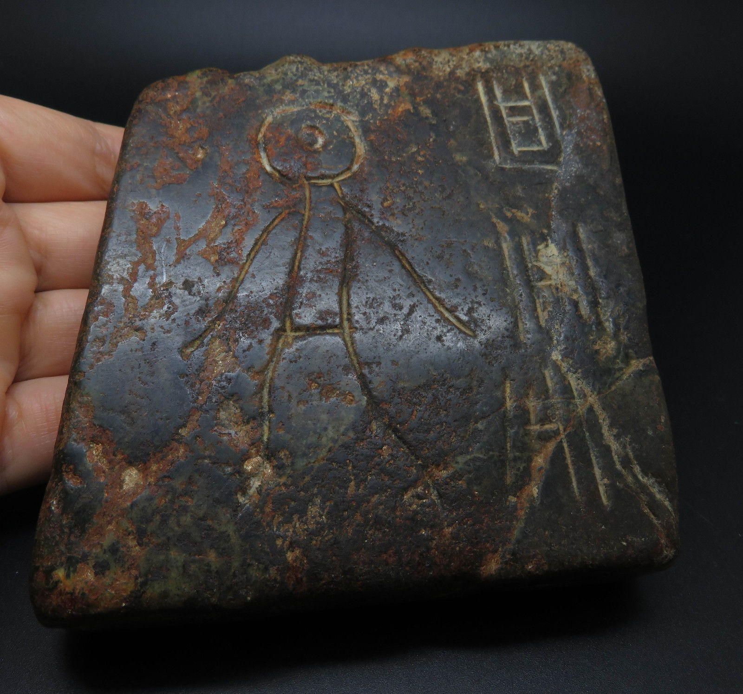

**Case no.: 1**

**Accession Number: A136**

**Formal Label:** EUR-Petroglyph-Anthropomorph-Concentric Circle Head-3 H figures-10,000 BCE

**Display Description:**

**This petroglyph panel features an anthropomorph with concentric circle for a head and three H symbols of unknown meaning. One element of the anthropomorph is arms as single curvilinear lines. The engraving appears to have been done with a metal blade, hence it is ascribed to the Iron Age of Europe. It is in the tradition of Pictish figures found at** ​ABELERMNO PICTISH STONE (CANMORE COLLECTION 1113054)  Scotland

 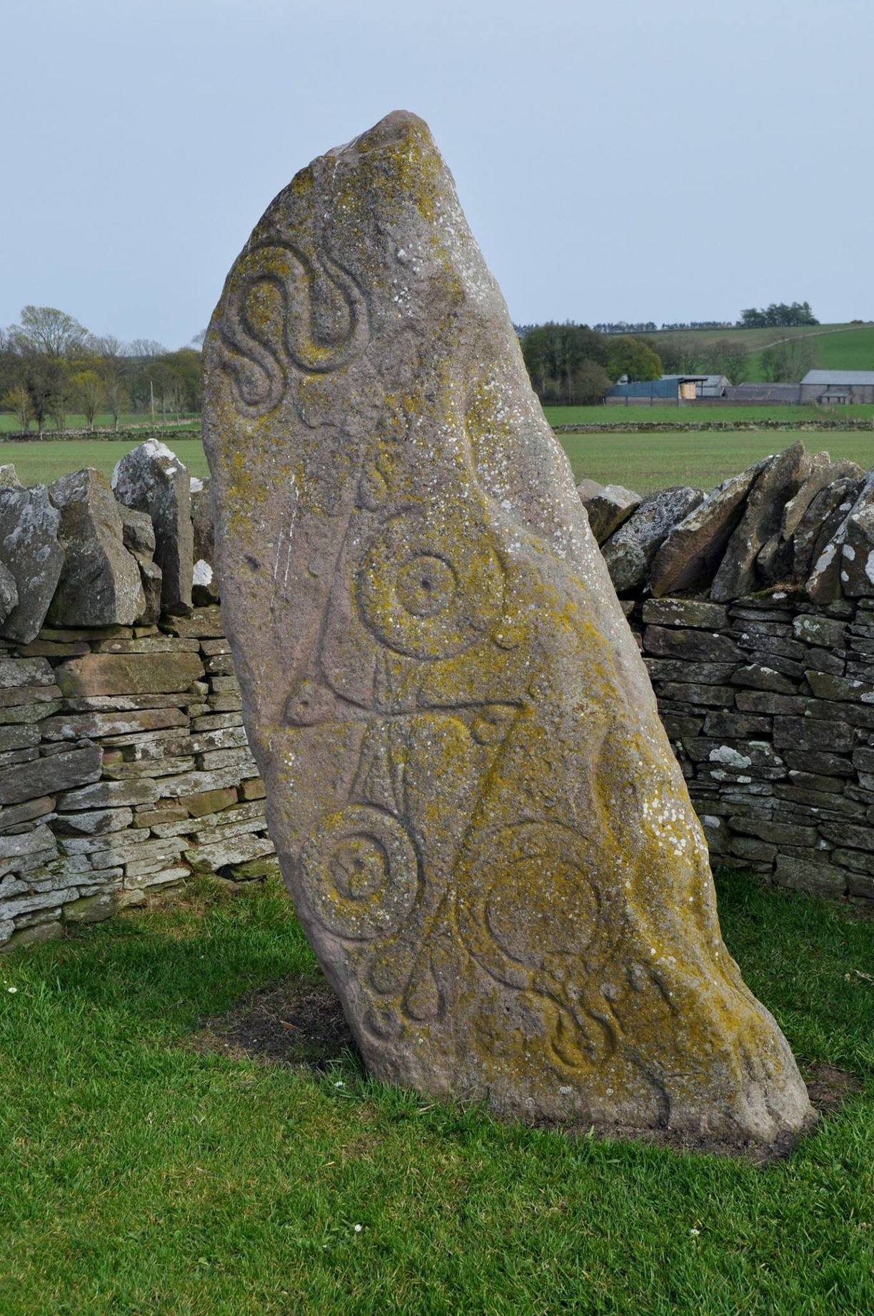

**LC Classification:**

**Date or Time Horizon:**

**Geographical Area:**

**Map:**

**GPS coordinates:**

**Cultural Affiliation:**

**Media:**

**Dimensions:**

**Weight:**

**Condition:**

**Provenance:**

**Discussion:**

**References:**